1. Online Food Delivery App – Mobile UI Design
Scenario:
A food delivery company wants a mobile application through which customers can browse restaurants, search for food, add items to a cart, and place orders.
Question:
Using Figma, design a mobile food delivery application with the following screens: 1. Login Screen – Email, password, Login button, and Forgot Password option. 2. Home Screen – Search bar, food categories, restaurant cards, and navigation bar.
3. Restaurant Menu Screen – Restaurant name, food items, prices, images, and Add button.
4. Cart Screen – Selected items, quantity, total amount, and Checkout button.
5. Order Confirmation Screen – Order number, total amount, delivery status, and estimated delivery time.
Figma requirements: Use Frames, Auto Layout, Components, icons, and Prototype interactions to connect the screens.
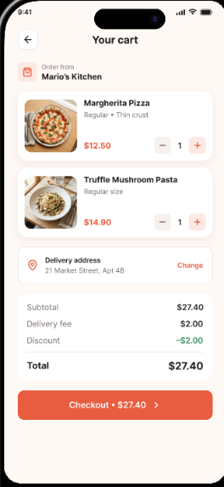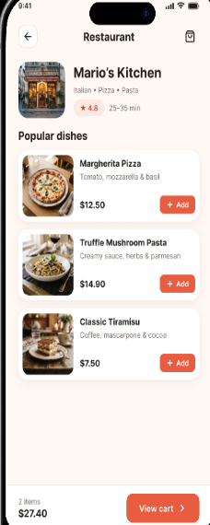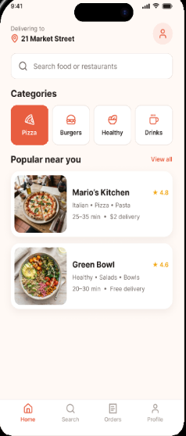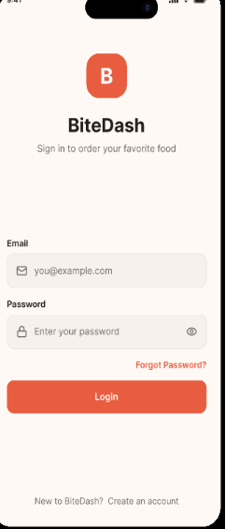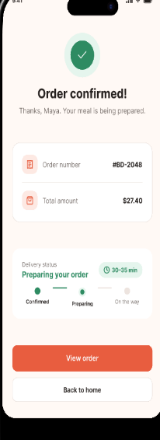

Student Attendance App – UI Design
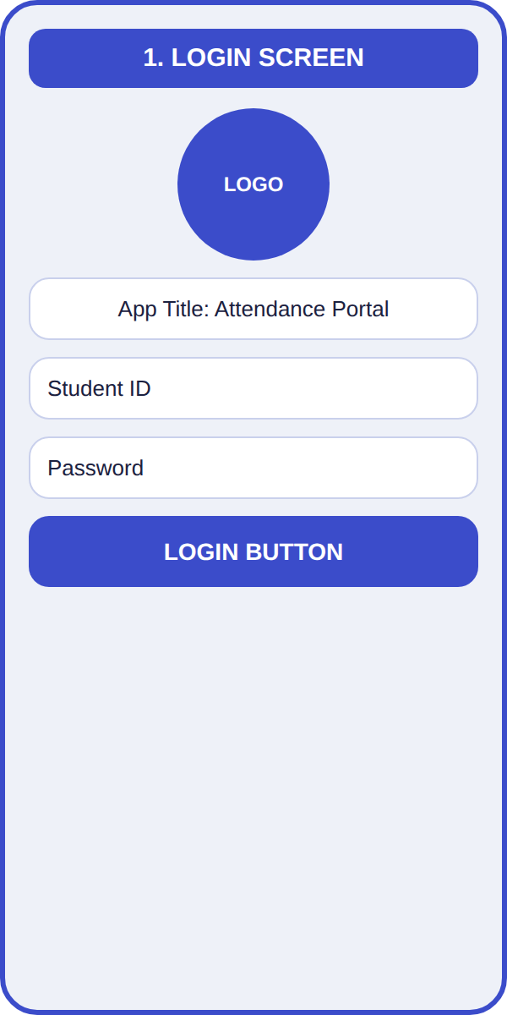  Login Screen | 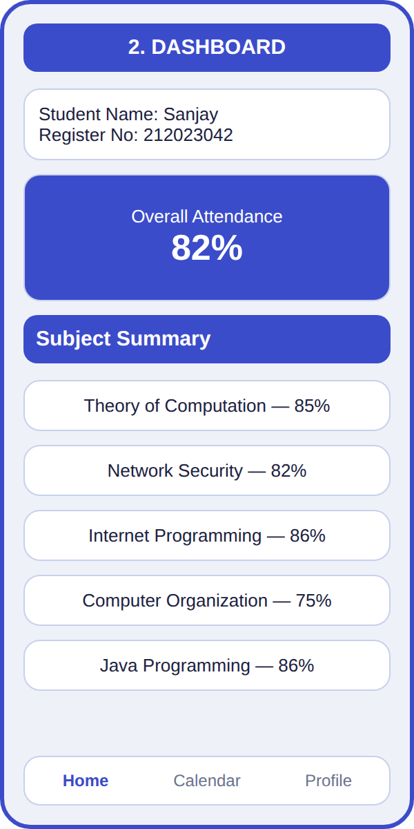  Dashboard | 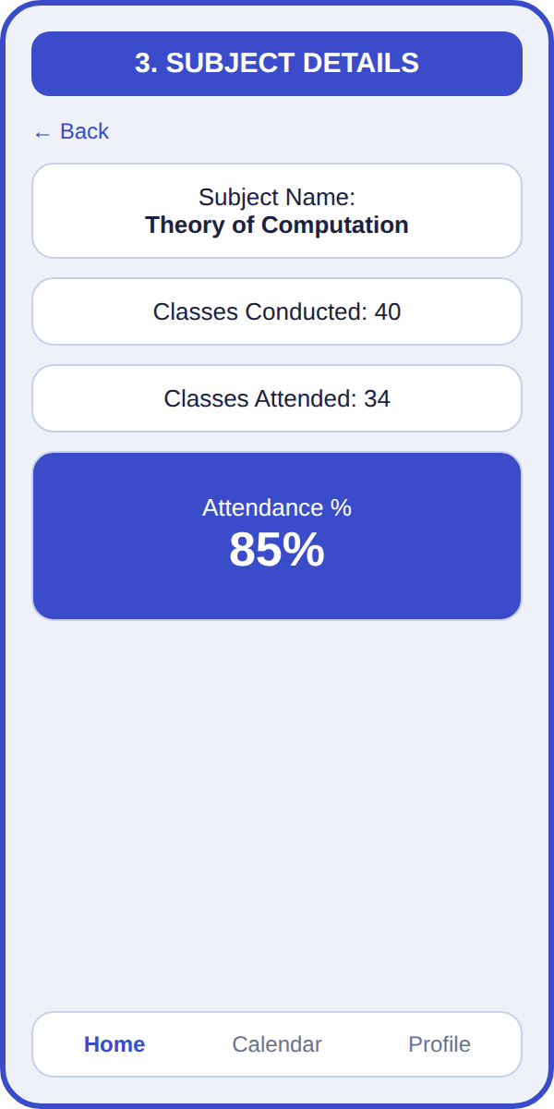  Subject Details
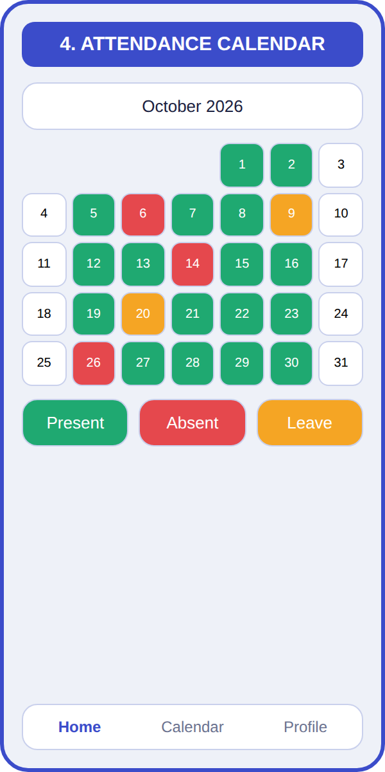  Attendance Calendar | 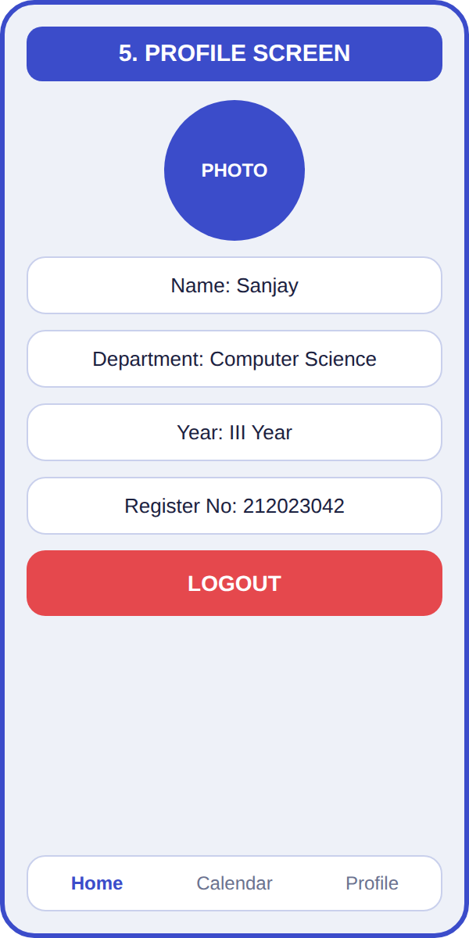  Profile Screen

E-Commerce Clothing App – UI Design
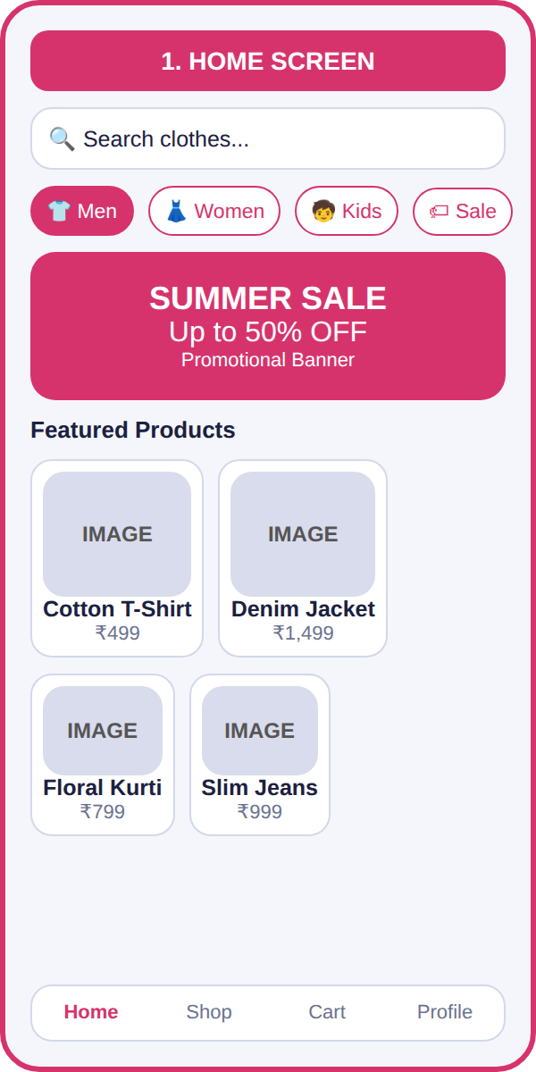  Home Screen | 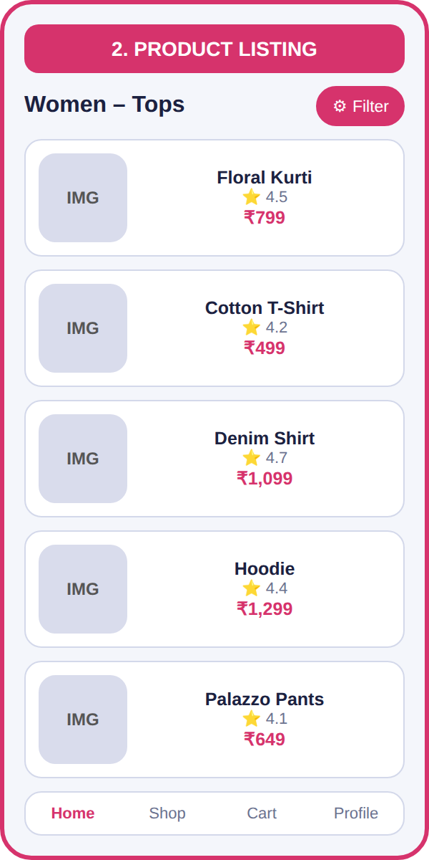  Product Listing | 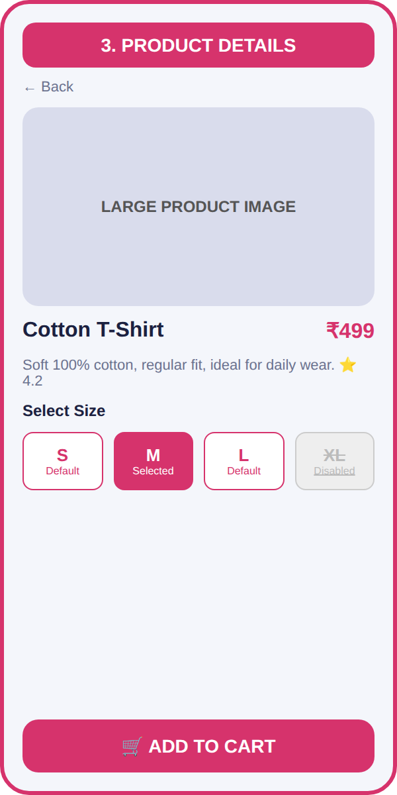  Product Details
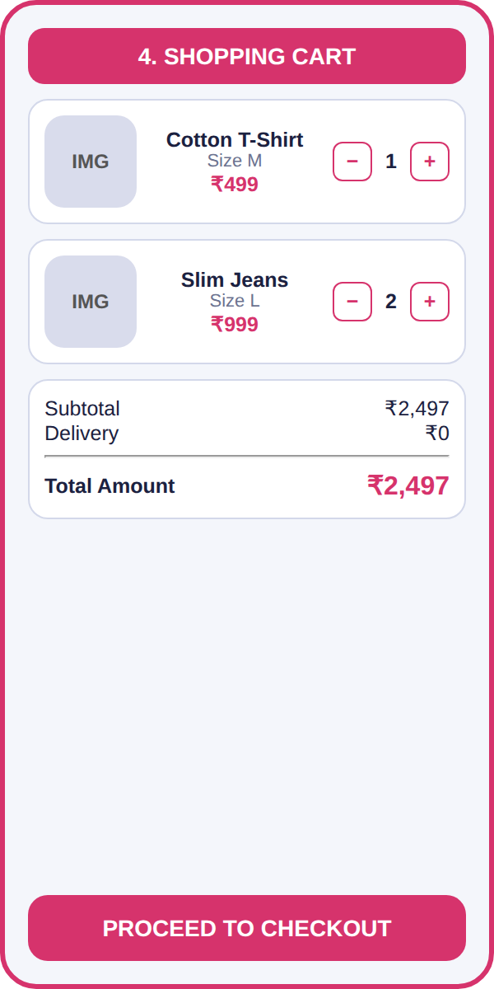 | 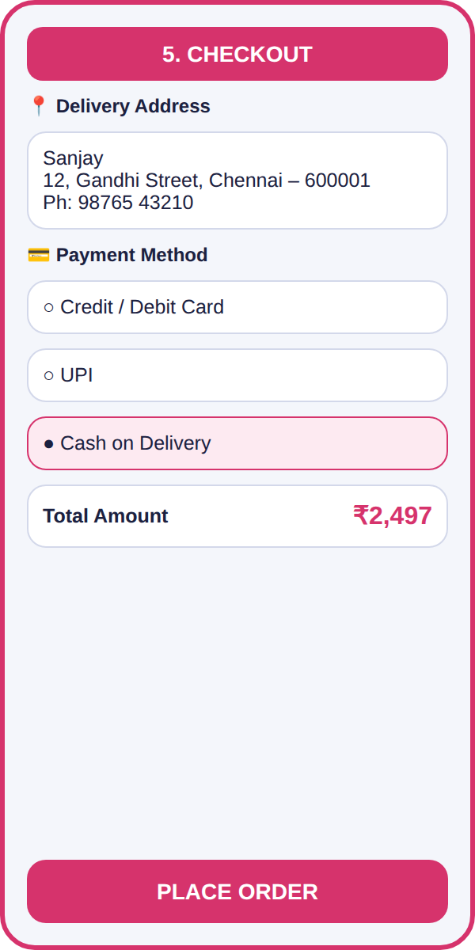t
Hospital Appointment Booking – UI Design
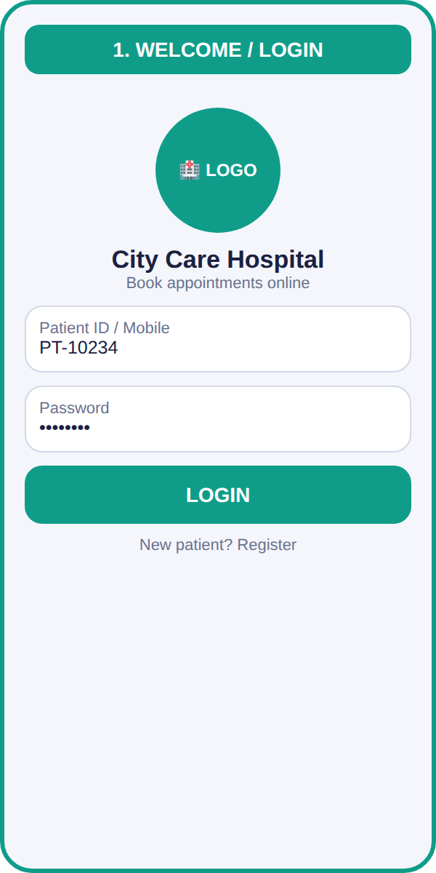  Welcome / Login | 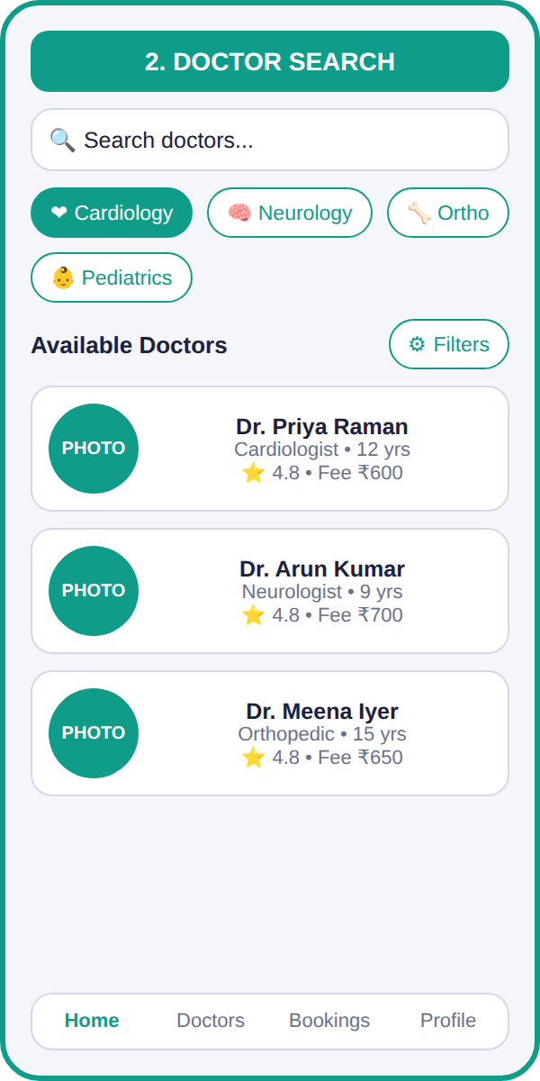  Doctor Search | 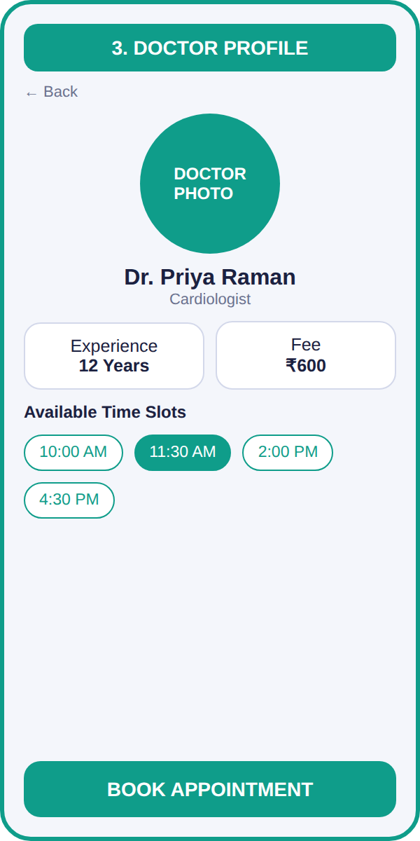  Doctor Profile
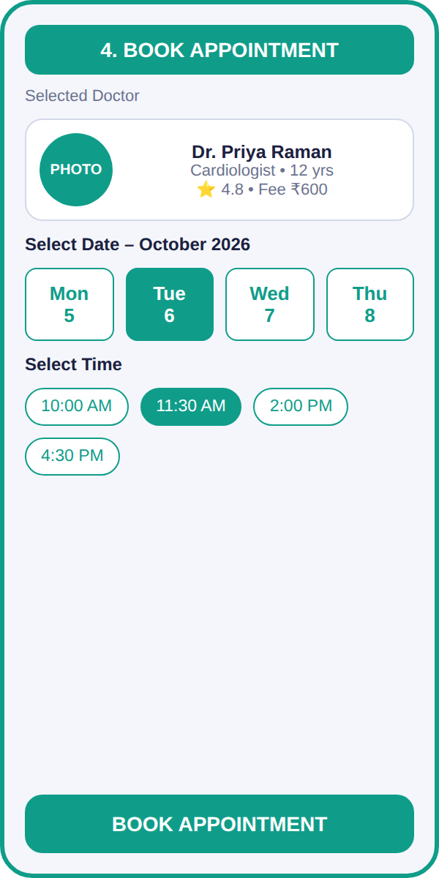  Appointment Booking | 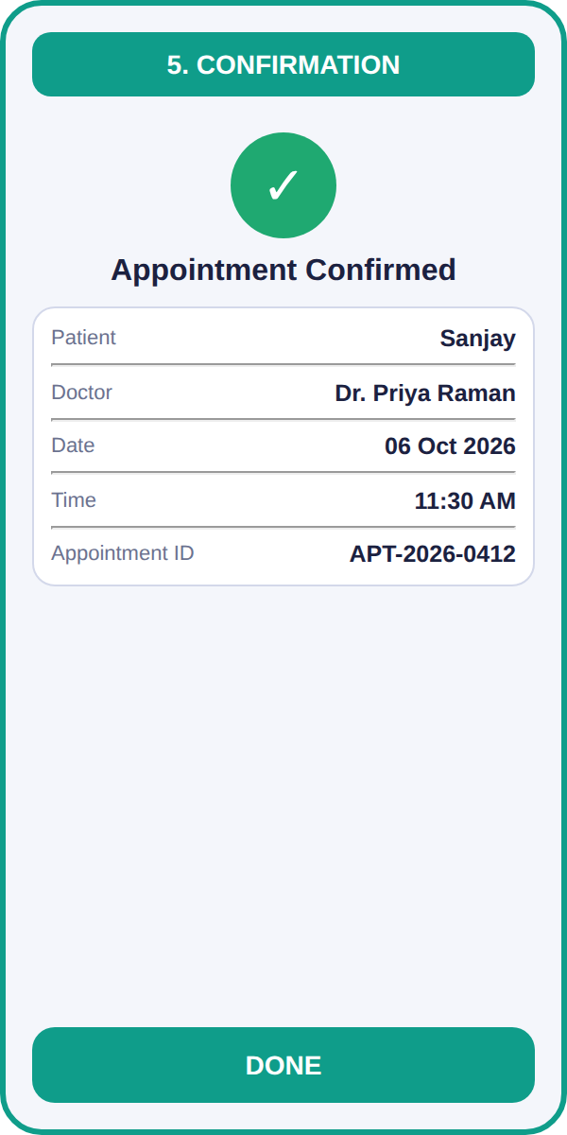  Confirmation
Technical Symposium Website – UI Design

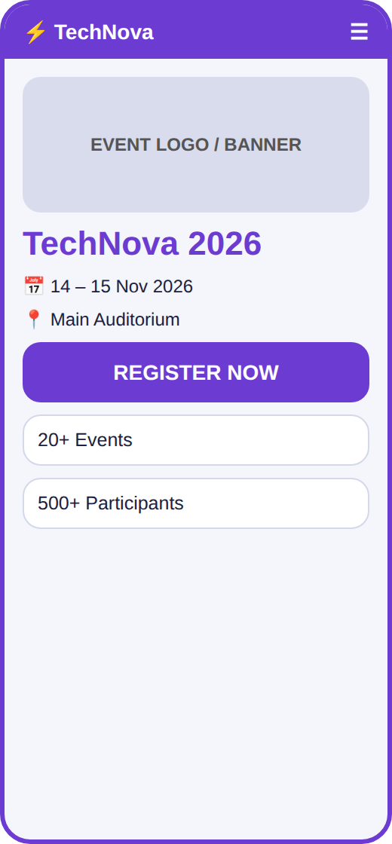  Home Page (Mobile) | 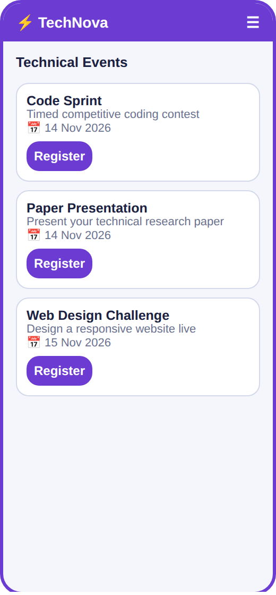  Events Page (Mobile) | 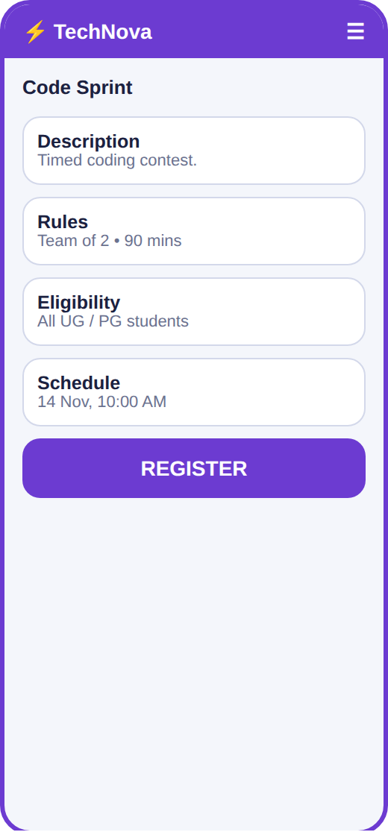  Event Details Page (Mobile)
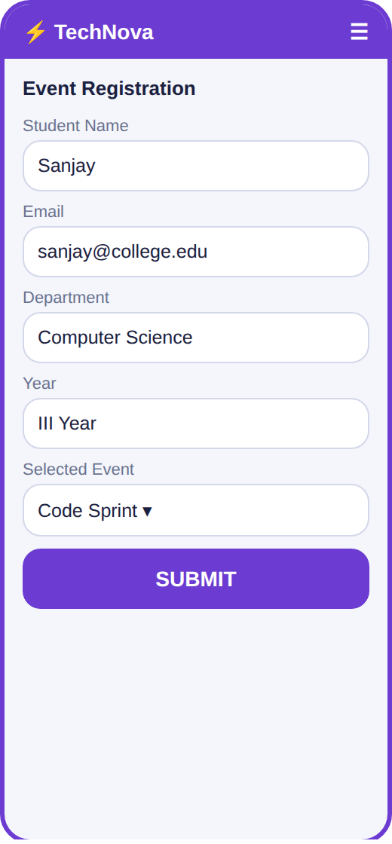  Registration Page (Mobile) | 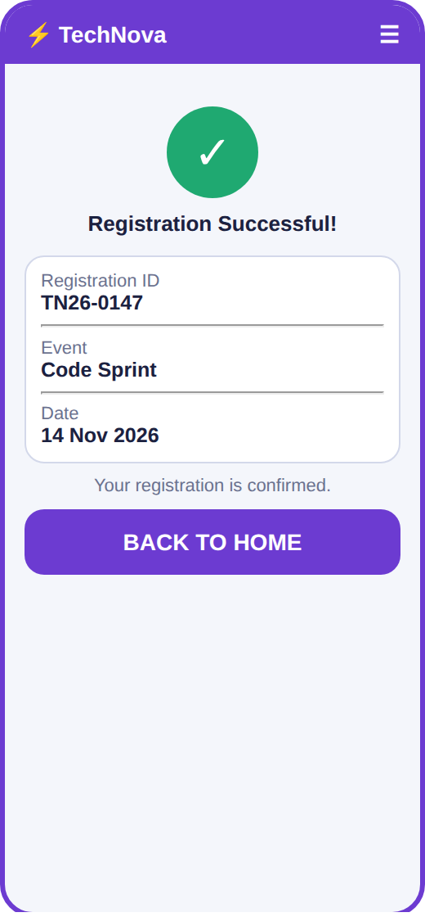  Confirmation Page (Mobile)

